# Final Report: Weather Impact on Class Attendance

## 1. Introduction

This project explores how weather conditions may influence class attendance. As a student based in Pendik, Istanbul, I manually recorded my daily class attendance and retrieved historical weather data (temperature, precipitation, and conditions) via the Visual Crossing API. My goal was to determine whether colder and wetter days correlate with lower attendance, using both statistical and visual analysis.

## 2. Hypothesis

Null Hypothesis (H₀): Weather conditions do not affect class attendance.

Alternative Hypothesis (H₁): Attendance is lower on cold (max temp < 10°C) and wet (precipitation > 0.2 mm) days.

## 3. Hypothesis Test Results

To test the hypothesis, an independent two-sample t-test was conducted between two groups:  
- Group A: Cold and rainy days  
- Group B: Other days  
  
Results:  
- T-statistic: -1.5156  
- P-value: 0.1738  
- Group A size: 7 days  
- Group B size: 63 days  
  
Conclusion: Since the p-value is greater than 0.05, we fail to reject the null hypothesis. However, the result suggests a directional trend (lower attendance on cold and rainy days) which may become significant with more data.

## 4. Data Visualizations & Interpretations

### 4.1 Correlation Matrix

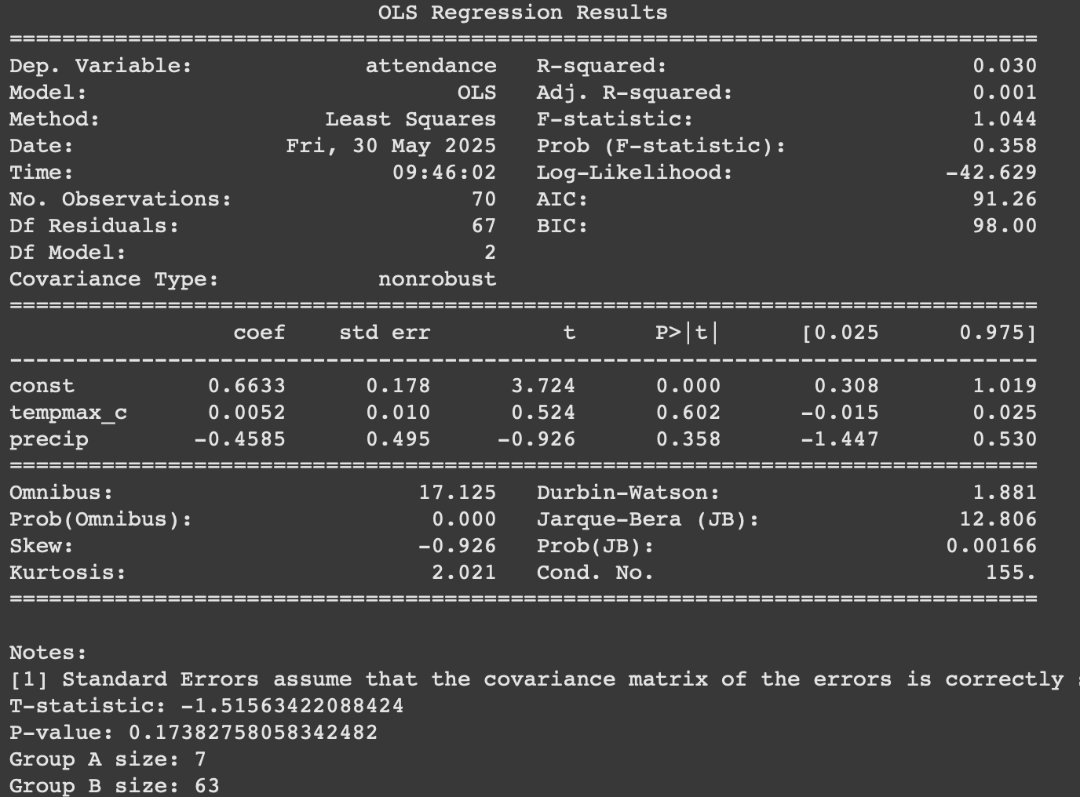

Attendance has a weak positive correlation with temperature and a weak negative correlation with precipitation.

### 4.2 Attendance vs. Max Temperature

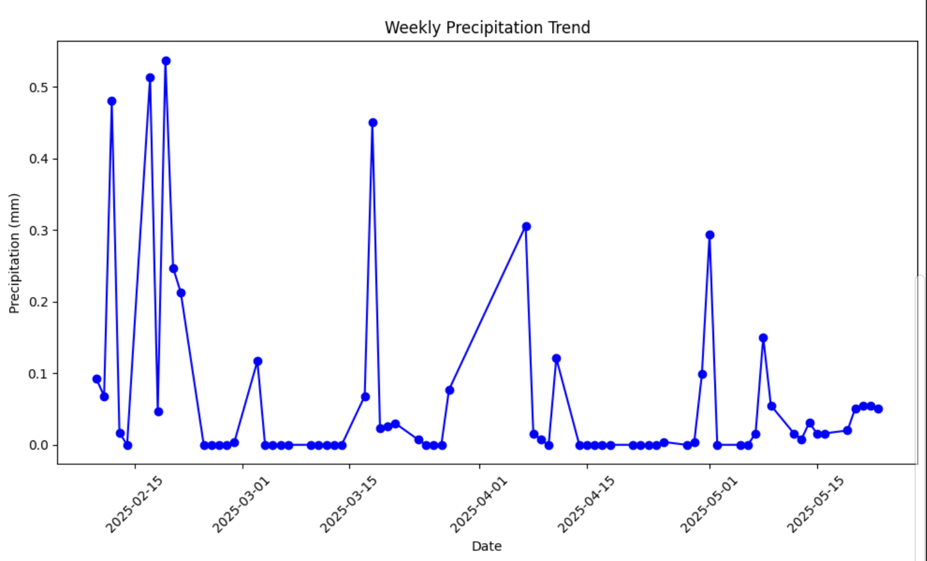

Attendance was lower when max temperature fell below 10°C, with highest attendance observed in the 15–25°C range.

### 4.3 Attendance vs. Precipitation

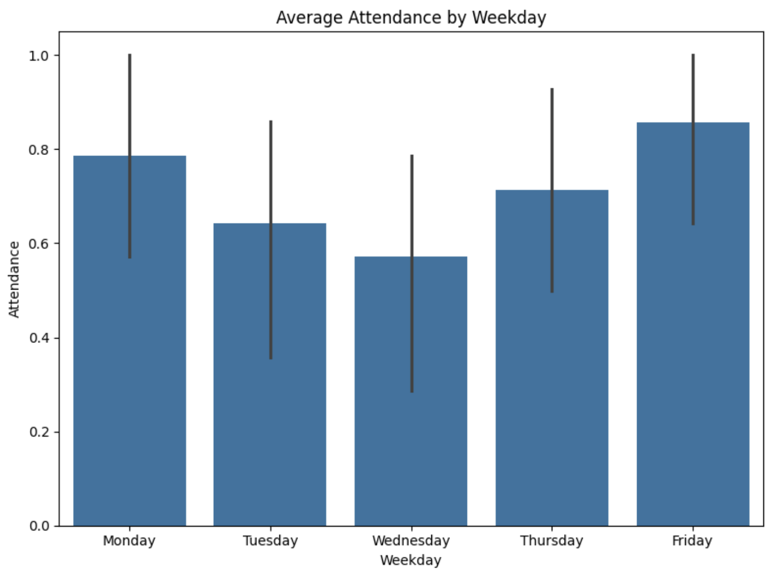

As precipitation increases, class attendance tends to decrease.

### 4.4 Attendance Over Time

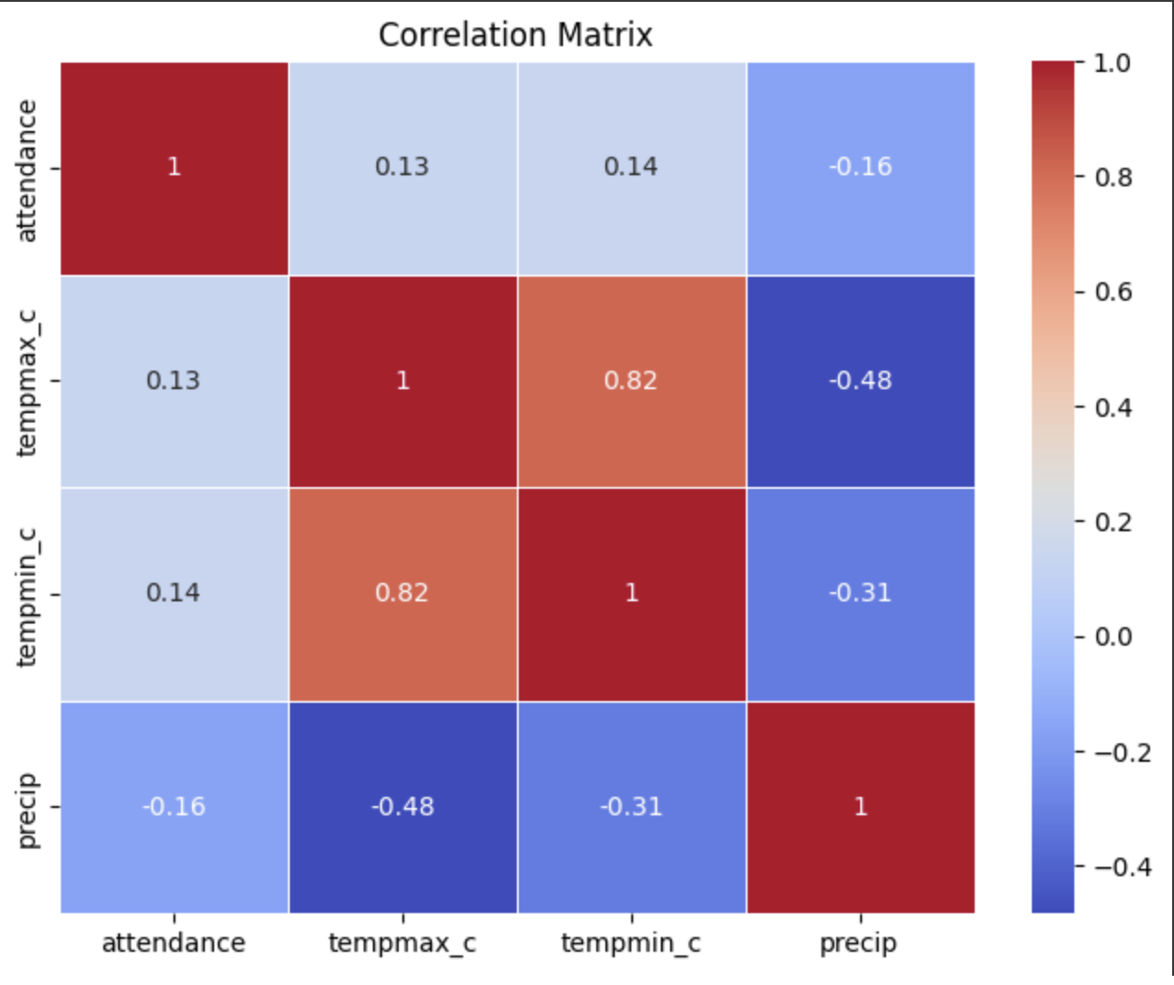

Attendance fluctuated during the semester. Several streaks of absence were observed during cold/wet weeks.

### 4.5 Average Attendance by Weekday

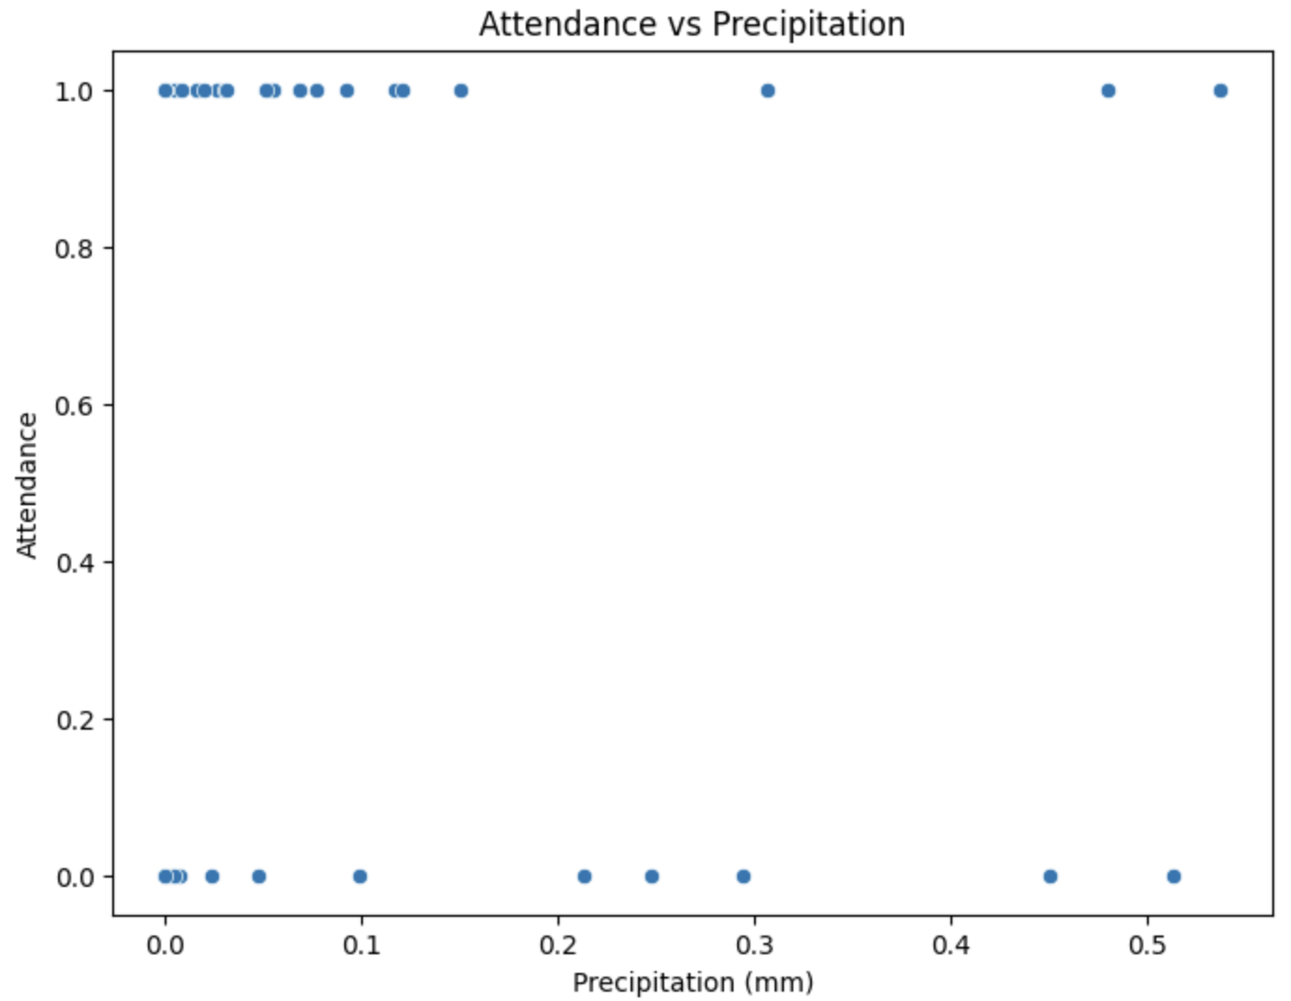

Fridays saw the highest average attendance while Wednesdays and Thursdays were lower.

### 4.6 Attendance by Weather Type

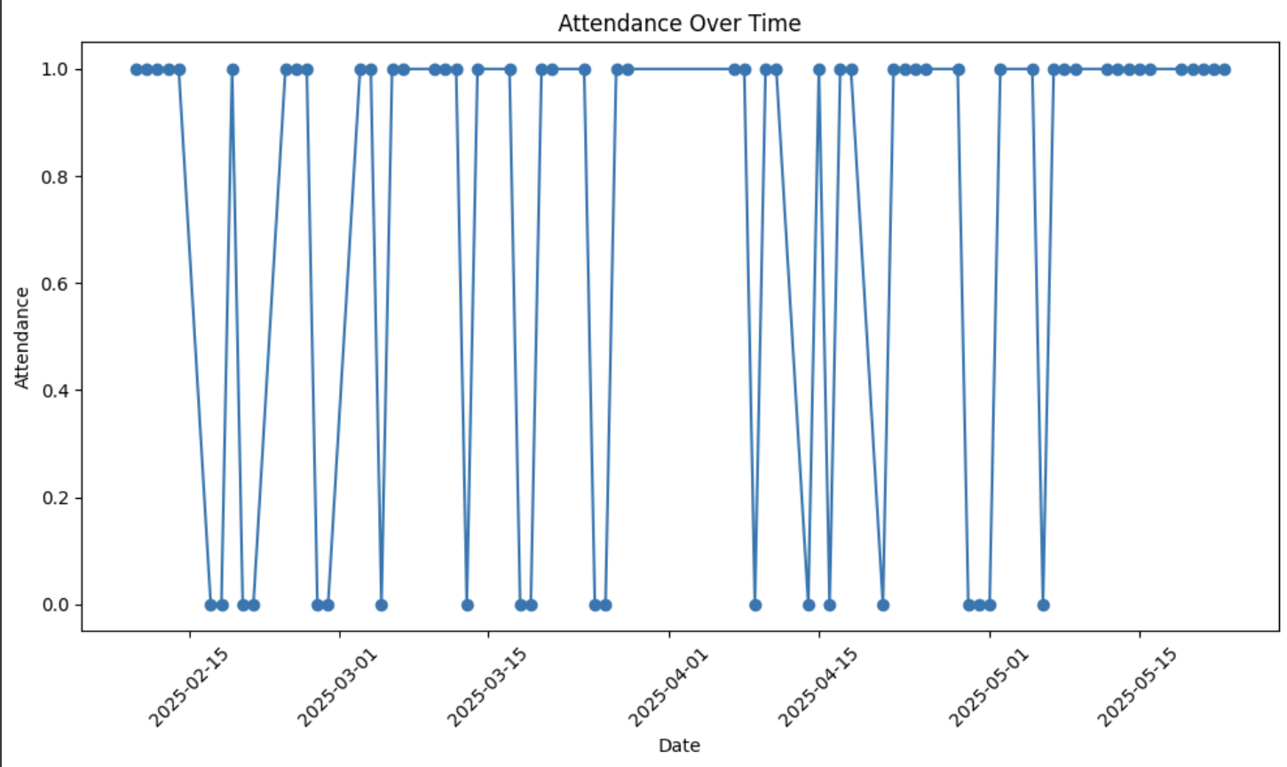

Clear/Cloudy days showed slightly lower attendance than Rain or Snow days. However, the sample size for snowy days was very limited.

### 4.7 Weekly Precipitation Trend

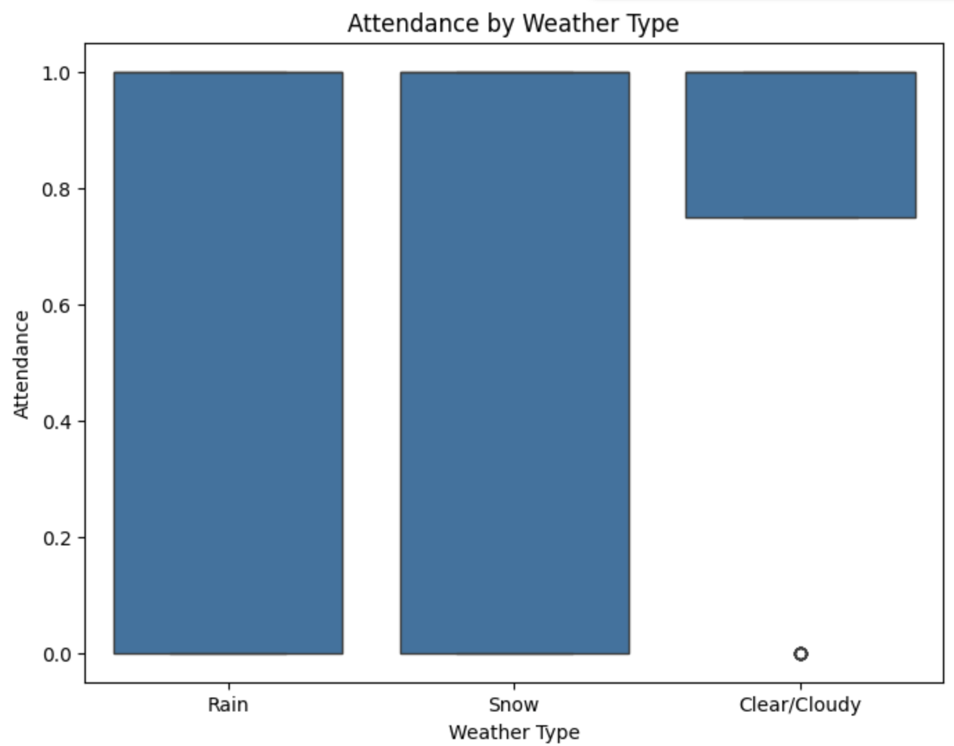

Rainfall was concentrated in early February and April. Long dry periods occurred in March and May.

### 4.8 Regression Summary

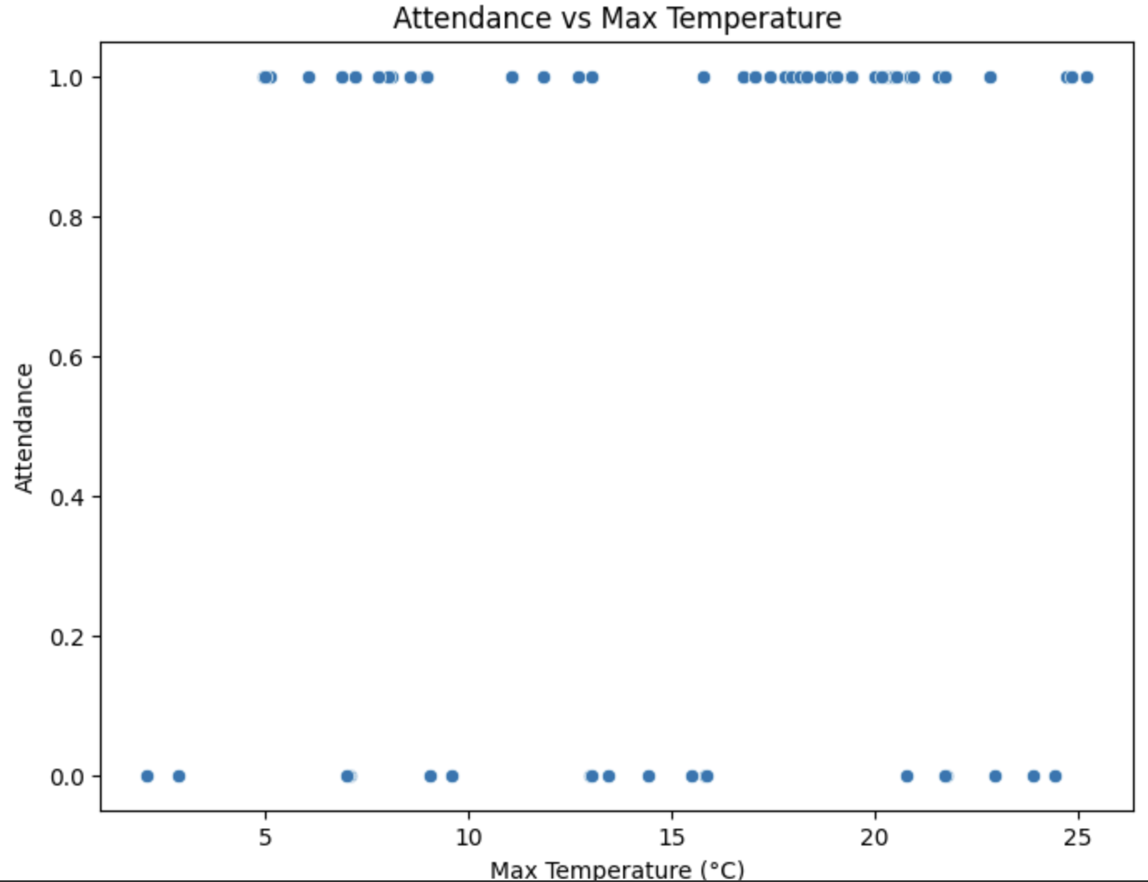

Regression analysis shows that precipitation has a negative effect on attendance, but not statistically significant (p > 0.05).

## 5. Conclusion

This study aimed to determine whether weather affects student class attendance. While statistical significance was not achieved, both visual trends and correlation values suggest a potential decrease in attendance on colder and wetter days. Future studies with more data and a broader participant base may yield stronger and more generalizable results.